Walking as Creative Fuel: A Splendid 1913 Celebration of How Solitary Walks Enliven “The Country of the Mind”

“Nature’s particular gift to the walker… is to set the mind jogging, to make it garrulous, exalted, a little mad maybe — certainly creative and suprasensitive.”

**BY MARIA POPOVA**

[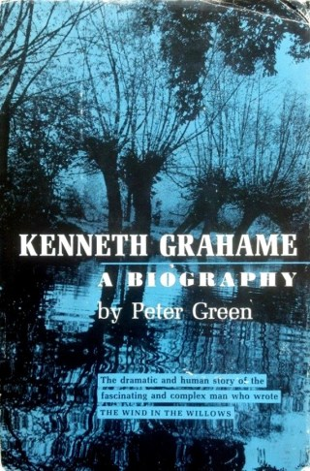](http://www.amazon.com/exec/obidos/ASIN/0719505488/braipick-20)

*“Every walk is a sort of crusade,”* Thoreau wrote in his [manifesto for the spirit of sauntering](https://www.brainpickings.org/2014/11/17/thoreau-walking/). And who hasn’t walked — in the silence of a winter forest, amid the orchestra of birds and insects in a summer field, across the urban jungle of a bustling city — to conquer some territory of their interior world? Artist Maira Kalman [sees walking as indispensable inspiration](https://www.brainpickings.org/2012/07/30/maira-kalman-thinking-feeling-interview/): *“I walk everywhere in the city. Any city. You see everything you need to see for a lifetime. Every emotion. Every condition. Every fashion. Every glory.”* For Rebecca Solnit, walking [“wanders so readily into religion, philosophy, landscape, urban policy, anatomy, allegory, and heartbreak.”](https://www.brainpickings.org/2015/06/03/wanderlust-rebecca-solnit-walking/)

Perched midway in time between Thoreau and Solnit is a timeless celebration of the psychological, creative, and spiritual rewards of walking by the Scottish writer **Kenneth Grahame** (March 8, 1859–July 6, 1932), best known for the 1908 children’s novel *The Wind in the Willows* — a book beloved by pioneering conservationist and marine biologist [Rachel Carson](https://www.brainpickings.org/tag/rachel-carson/), whose own [splendid prose about nature](https://www.brainpickings.org/2017/09/20/rachel-carson-lost-woods-the-real-world-around-us/) shares a kindred sensibility with Grahame’s.

[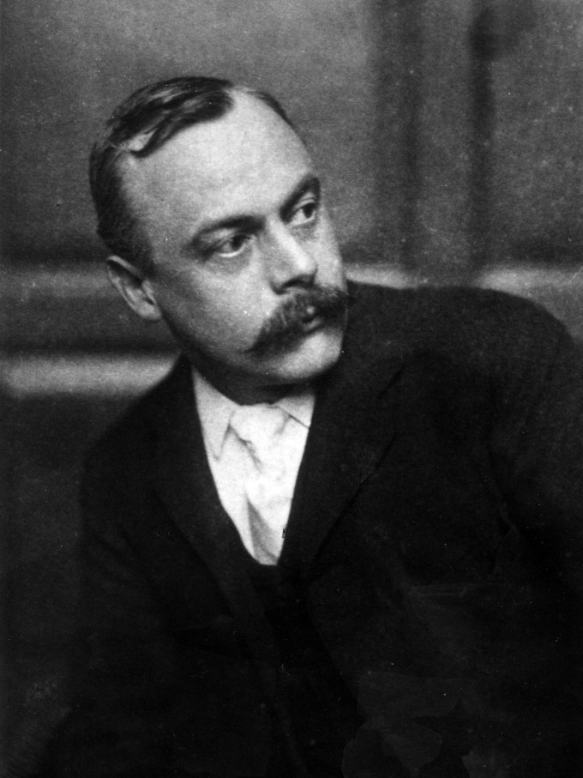](http://www.amazon.com/exec/obidos/ASIN/0719505488/braipick-20)Kenneth Grahame

Five years after publishing *The Wind in the Willows*, Grahame penned a beautiful short essay for a commemorative issue of his old boarding school magazine. Titled “The Fellow that Goes Alone” and only ever published in Peter Green’s 1959 biography [***Kenneth Grahame***](http://www.amazon.com/exec/obidos/ASIN/0719505488/braipick-20) ([*public library*](http://www.worldcat.org/title/kenneth-grahame-1859-1932-a-study-of-his-life-work-and-times-by-peter-green/oclc/459560678&referer=brief_results)), it serenades “the country of the mind” we visit whenever we take long solitary walks in nature.

With an eye to “all those who of set purpose choose to walk alone, who know the special grace attaching to it,” Grahame writes:

Nature’s particular gift to the walker, through the semi-mechanical act of walking — a gift no other form of exercise seems to transmit in the same high degree — is to set the mind jogging, to make it garrulous, exalted, a little mad maybe — certainly creative and suprasensitive, until at last it really seems to be outside of you and as if it were talking to you whilst you are talking back to it. Then everything gradually seems to join in, sun and the wind, the white road and the dusty hedges, the spirit of the season, whichever that may be, the friendly old earth that is pushing life firth of every sort under your feet or spell-bound in a death-like winter trance, till you walk in the midst of a blessed company, immersed in a dream-talk far transcending any possible human conversation. Time enough, later, for that…; here and now, the mind has shaken off its harness, is snorting and kicking up heels like a colt in a meadow.

In a sentiment which, today, radiates a gentle admonition against the self-defeating impulse to evacuate the moment in order to capture it — in a status update, in an Instagram photo — Grahame observes:

Not a fiftieth part of all your happy imaginings will you ever, later, recapture, note down, reduce to dull inadequate words; but meantime the mind has stretched itself and had its holiday.

[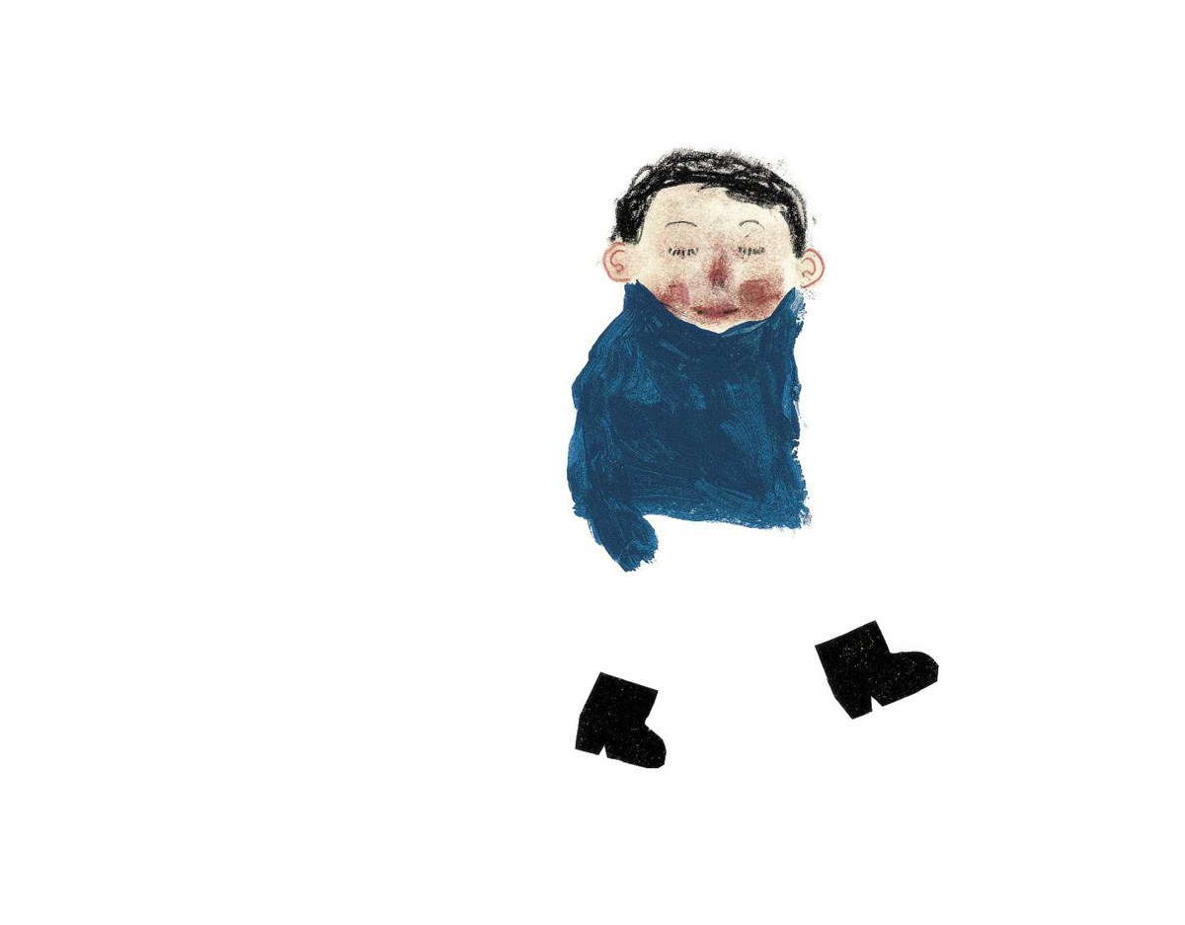](https://www.brainpickings.org/2016/10/13/what-color-is-the-wind-anne-herbauts/)Art from [*What Color Is the Wind?*](https://www.brainpickings.org/2016/10/13/what-color-is-the-wind-anne-herbauts/) by Anne Herbauts

Nearly a century before Wendell Berry’s poetic insistence that in true solitude [“one’s inner voices become audible”](https://www.brainpickings.org/2014/12/17/wendell-berry-pride-despair-solitude/) and modern psychology’s finding that [a capacity for “fertile solitude” is the seat of the imagination](https://www.brainpickings.org/2014/07/18/adam-phillips-on-risk-and-solitude/), Grahame writes:

This emancipation is only attained in solitude, the solitude which the unseen companions demand before they will come out and talk to you; for, be he who may, if there is another fellow present, your mind has to trot between shafts.

A certain amount of “shafts,” indeed, is helpful, as setting the mind more free; and so the high road, while it should always give way to the field path when choice offers, still has this particular virtue, that it takes charge of you — your body, that is to say. Its hedges hold you in friendly steering-reins, its milestones and finger-posts are always on hand, with information succinct and free from frills; and it always gets *somewhere*, sooner or later. So you are nursed along your way, and the mind may soar in cloudland and never need to be pulled earthwards by any string. But this is as much company as you ought to require, the comradeship of the road you walk on, the road which will look after you and attend to such facts as must not be overlooked. Of course the best sort of walk is the one on which it doesn’t matter twopence whether you get anywhere at all at any time or not; and the second best is the one on which the hard facts of routes, times, or trains give you nothing to worry about.

In consonance with artist Agnes Martin’s quiet conviction that [“the best things in life happen to you when you’re alone,”](https://www.brainpickings.org/2013/03/22/agnes-martin-1997-interview/) Grahame writes:

As for adventures, if they are the game you hunt, everyone’s experience will remind him that the best adventures of his life were pursued and achieved, or came suddenly to him unsought, when he was alone. For company too often means compromise, discretion, the choice of the sweetly reasonable. It is difficult to be mad in company; yet but a touch of lunacy in action will open magic doors to rare and unforgettable experiences.

But all these are only the by-products, the casual gains, of walking alone. The high converse, the high adventures, will be in the country of the mind.