**It is solved by walking**

**The path to fixing our broken communities is forged by footsteps.**

[Antonia Malchik](https://www.hcn.org/author_search?getAuthor=Antonia%20Malchik&sort_on=PublicationDate&sort_order=descending) ESSAYMay 13, 2019From the [print edition](https://www.hcn.org/issues/51.8)

[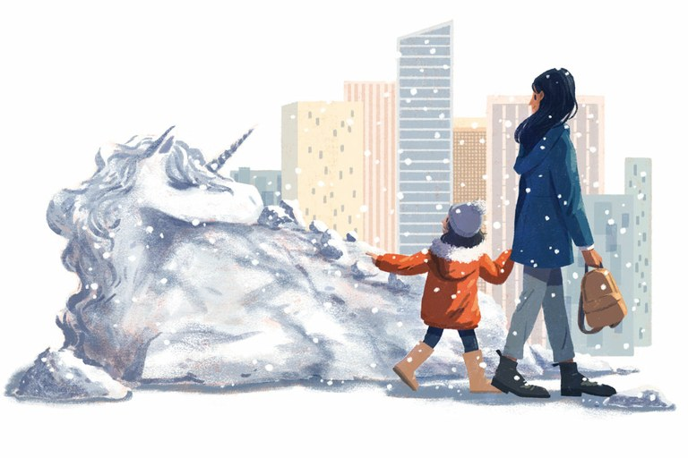](https://www.hcn.org/issues/51.8/it-is-solved-by-walking/walkingillo-jpg/image_view_fullscreen)

Illustration by Ran Zheng for High Country News

In the middle of our walk home from school, my daughter paused to pick up a handful of snow and shape it into a ball. “This is a unicorn egg,” she told me, planting it in the thigh-high snowbank next to the sidewalk. This was the fourth unicorn egg we’d planted that day, along with a dog egg and an allicorn egg (an allicorn, for those not in the know, is a unicorn pegasus) and one particularly large egg that would eventually, in whatever mythology we were creating, birth an entire menagerie. While she made up stories, rambling on about a unicorn and a rock and a frog in a river, I breathed deep, lingering over the smell of wet snow that hovered between a chinook-like dampness and the bite of our recent sub-zero temperatures.

Ever since my family made the move from an exurban house where we were completely dependent on our two cars into a walkable town, the effects of walking have crept into all corners of our life, from my own health to our two kids’ sense of independence. We’ve been walking or biking to school most days for nearly three years now, ever since my daughter started kindergarten. At first, she preferred biking to the half-hour walk, but the benefits of wandering — and the imaginings it can inspire — gradually took over the desire for speed.

I’ve also spent the last two years writing and researching a book about walking. In the process, I clocked upward of 2,000 miles on foot, in Denver and New York City, in Montana’s Great Bear Wilderness and along England’s Norfolk coast, and in my hometown in northwest Montana. What walking has given me can never be distilled onto a Fitbit or calorie counting app. Rather, I am far more aware now of how my senses help my brain filter and interpret the vast sea of information constantly shifting around me, allowing me to not just move through the world, but to understand my own place within it. I’ve seen the same transformation in my son: At 10, he started walking to and from school by himself, and realized that he could also walk to after-school karate or wander to the library or a friend’s house and then home again without his parents. Many of his friends who were driven everywhere didn’t know how to get from one side of town to the other, a 15- to 20-minute walk. In walking, my son discovered a sense of ownership over his own life, a kind of self-determination that’s rare for a young child.

Walking a thousand miles a year hasn’t given me a tidy list for how to live a good and effective life that I could stick up on the refrigerator. But it’s kept the promise contained in the Latin phrase *solvitur ambulando*,   
  
or “it is solved by walking.” Originally used to describe a premise that is explored through practical experiment, the phrase has been used by thinkers, writers and travelers throughout millennia of written history, people who believed — because they walked and found it to be true — that walking was an answer to the stuck thought, the sorrowing heart, the moral dilemma. It is the realization that freedom of the mind is intertwined with freedom of movement.

*Homo sapiens*evolved from various hominin species that spent something like 6 million years learning to walk upright on two feet and developing habits of motion, work and social relationships alongside that evolution. So it’s no surprise that walking helps us build and maintain community, in large part by developing relationships with people of varying backgrounds through seemingly inconsequential daily interactions. It is through walking — and by making walkable, mobile lives possible for all of us, not just a privileged few — that we can begin to restore the communities fractured by car-centric design, lives spent online and a polarized social-political sphere. Walking, alone or with others, allows us to question the rigidity of our own beliefs, whether it’s a political ideology or the potential of snowballs to turn into unicorns.

I’ve walked off sadness, anxiety, anger and fear, wandering until whatever dark emotion gripped me receded enough that I could place it in perspective. Depression in particular has lost its power. When that familiar numbness creeps through my fingers and heart, I force myself to step outside no matter the weather, to walk a little, even just to the mailbox. Not once has it failed to remind me that life is a beautiful, complex thing worth living.

That is what I thought of as I watched my daughter play in the snowbanks, drinking in the cold air: That there is power in this act of walking together, that we’re building something curiously resilient. Even if the eggs my daughter plants never hatch into baby unicorns, I know that there is magic in our walking.

*Antonia Malchik is a freelance writer. She is the author of*A Walking Life*, a nonfiction book about walking, and lives in Whitefish, Montana. Email*High Country News*at*[*editor@hcn.org*](http://editor@hcn.org/)*or submit a*[*letter to the editor*](https://www.hcn.org/feedback/contact-us)*.*